SAVEETHA INSTITUTE OF MEDICAL AND TECHNICAL SCIENCES
SIMATS ENGINEERING

ECA54 – ELECTROMAGNETIC FIELDS AND WAVES
CO1 ASSESSMENT 4

Electrostatic Field Characterization: From Charge Distribution to Energy and Design Verification

Scenario-Based Assignment: Air-Filled Coaxial Cylindrical High-Voltage Structure

Submitted by: Sumithra.M
Register Number: 192512025
Course name : EMF
Maximum Marks: 100

ABSTRACT
This report presents a complete engineering analysis of an air-filled coaxial cylindrical high-voltage electrostatic sensing/insulation structure before prototype fabrication. The structure has an inner conductor of radius a = 5 mm, an outer shield of inner radius b = 20 mm, an active length L = 100 mm and an applied potential difference V₀ = 5 kV, with the outer conductor as the 0 V reference.
The problem is interpreted, two analytical methods (Coulomb’s law and Gauss’s law) are compared using a weighted decision matrix, and Gauss’s law is selected as the primary method. The electric field intensity E(r), the electric flux density D(r), the potential V(r), the charge per unit length, the total charge, the capacitance and the stored energy are derived. A MATLAB program is then developed to evaluate and plot all quantities, to report the values at r = 5, 10, 15 and 20 mm, and to verify the analytical relationships numerically. A parameter study on the inner and outer radii is carried out, and the design is finally verified against the specification.
The maximum electric field is E_{max} = 721.35 kV/m at r = a = 5 mm, the charge per unit length is 200.65 nC/m, the total charge is 20.07 nC, the capacitance is 4.013 pF and the stored energy is 50.16 μJ. The maximum field is about 24 % of the approximate dielectric strength of air (3 MV/m), so the final engineering decision is YES – the design is accepted.

1. PROBLEM STATEMENT AND GIVEN DATA
An engineering team is developing a cylindrical high-voltage electrostatic sensing/insulation structure in air. The field must be analysed before fabrication so that the electric field, electric flux density, potential distribution and stored electrostatic energy are known and the selected geometry can be justified. The structure is an air-filled coaxial cylindrical arrangement consisting of an inner conducting electrode and an outer conducting shield. The field is predominantly radial in the region between the conductors.

Design specifications (given data)

Parameter | Given data
Inner conductor radius, a | 5 mm = 5 × 10⁻³ m
Outer conductor inner radius, b | 20 mm = 20 × 10⁻³ m
Active length, L | 100 mm = 0.1 m
Applied potential difference, V₀ | 5 kV = 5000 V
Medium | Air / free space, ε_{r} ≈ 1
Reference potential | Outer conductor = 0 V

What must be determined

- The final mathematical field model.
- Whether Coulomb’s law or Gauss’s law should be the primary analytical method.
- The electric-field and flux-density distributions.
- The potential distribution and the stored electrostatic energy.
- The most appropriate computational verification approach (MATLAB).

Engineering process followed

The report follows the required engineering workflow:
REQUIREMENT → MODEL / ALTERNATIVES → ANALYSIS → CALCULATION / COMPUTATION → COMPARISON → VERIFICATION → ENGINEERING DECISION
Stages 1 to 6 of the assessment correspond to these steps, and the final verification table and final engineering decision close the report.

2. STAGE 1 – INTERPRET THE ELECTROSTATIC DESIGN REQUIREMENT

2.1 Physical meaning of a, b and L

The inner radius a = 5 mm is the radius of the live electrode. It controls the curvature of the electrode surface and therefore the highest electric field in the structure. The outer radius b = 20 mm is the radius of the grounded shield, where the field lines terminate. The radial gap b − a = 15 mm is the air insulation thickness, and the ratio b/a = 4 fixes the shape of the field and the capacitance.
The active length L = 100 mm is the axial length over which the two electrodes face each other. Under the ideal model, charge, capacitance and energy per unit length are simply multiplied by L to obtain the total values. Since L/b = 5, the structure is reasonably long compared with its radial dimensions, which supports the long-cylinder approximation.
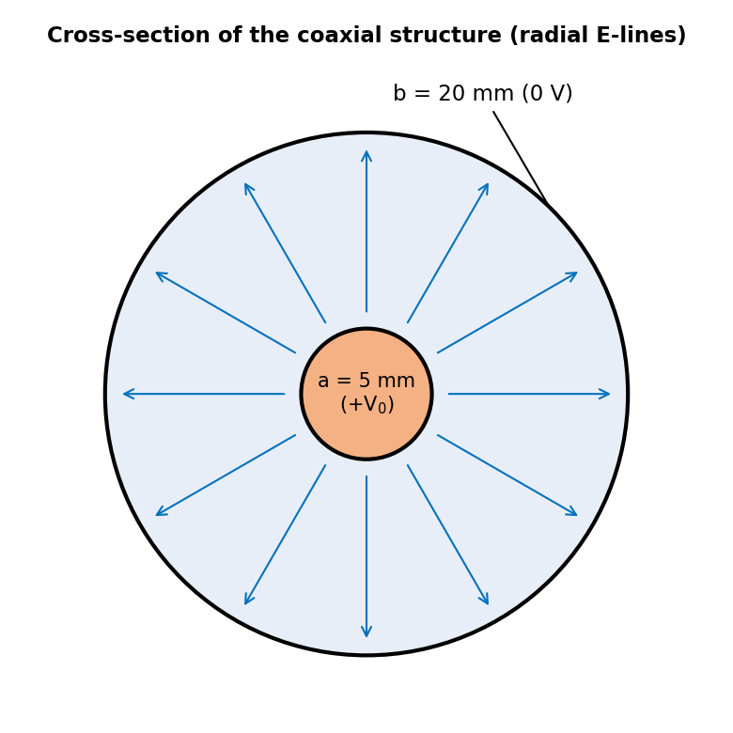
Figure 1: Cross-section of the coaxial structure showing the radial field lines

2.2 Region in which the field exists

Under the ideal coaxial assumption, the electric field exists only in the air-filled annular region a < r < b and over the active length 0 < z < L. Inside the metal of the inner conductor (r < a) and inside the metal of the shield, the electrostatic field is zero, because free charges in a conductor redistribute until E = 0 inside. All the free charge therefore sits on the surface of the inner conductor (positive) and on the inner surface of the shield (negative).

2.3 Symmetry and direction of the field

The geometry is invariant with respect to rotation about the axis (azimuthal symmetry, ∂/∂φ = 0) and, for a long structure, invariant along the axis (∂/∂z = 0). Hence E depends only on the radial coordinate r. By symmetry the φ and z components must vanish, so
E = E_{r}(r) a_{r}
Because the inner conductor is at the higher potential (+5 kV) and the outer conductor is at 0 V, the field points radially outward from the inner electrode towards the shield, in the direction of decreasing potential.

2.4 Material parameters

The medium is air, modelled as free space: ε = ε₀ε_{r} with ε₀ = 8.854 × 10⁻¹² F/m and ε_{r} ≈ 1, so ε ≈ ε₀. Air is linear, isotropic and homogeneous, hence D = εE. The dielectric strength of dry air is taken as approximately 3 MV/m (3 × 10⁶ V/m), which is the reference limit for the insulation check in Stage 6.

2.5 Quantities required to assess the design

Quantity | Symbol | Unit
Electric field intensity | E | V/m
Electric flux density | D | C/m²
Electric potential | V | V
Charge per unit length / total charge | ρ_{l} / Q | C/m / C
Capacitance per unit length / total | C′ / C | F/m / F
Stored electrostatic energy | W | J

2.6 Assumptions and practical limitations
- The cylinders are infinitely long in the field calculation (end and fringing effects are neglected; their size is estimated in Stage 2).
- The two cylinders are perfectly concentric, with smooth surfaces and perfect conductivity.
- The field is purely electrostatic (DC) with no space charge in the air.
- Air is uniform with ε_{r} = 1; humidity, temperature and pressure effects are ignored.
- In practice, surface roughness, electrode eccentricity, insulating supports and corona or breakdown phenomena can raise the local field above the ideal value.

2.7 Design Requirement Statement

Design Requirement Statement: Determine E(r), D(r), V(r), charge and energy in the air-filled region a < r < b of a coaxial structure with a = 5 mm, b = 20 mm, L = 100 mm and V₀ = 5 kV (outer conductor at 0 V), and verify that the maximum field stays safely below the dielectric strength of air so that the geometry can be approved for fabrication.

3. STAGE 2 – SELECT THE ELECTROSTATIC FIELD ANALYSIS METHOD

3.1 Alternative 1: Coulomb’s law with superposition
Coulomb’s law gives the field of a charge distribution by superposition. For a line charge ρ_{l} along the z-axis, the field at radial distance r in the plane z = 0 is
E_{r} = ∫ ρ_{l} r dz / [4πε (r² + z²)^{3/2}]
For an infinitely long line, using ∫ r dz/(r² + z²)^{3/2} from −∞ to +∞ = 2/r, the result is
E_{r} = ρ_{l} / (2πε r)
For a finite length L the limits become −L/2 to +L/2, and the mid-plane field is reduced by the factor (L/2)/√(r² + (L/2)²). The method works without perfect symmetry, but it requires the charge distribution to be known first. Here only the potential difference V₀ is specified, so ρ_{l} is unknown and a uniform surface charge must be assumed – which itself relies on the symmetry.

3.2 Alternative 2: Gauss’s law
Gauss’s law states that the flux of D through a closed surface equals the enclosed free charge. Choose a coaxial cylindrical Gaussian surface of radius r (a < r < b) and arbitrary length ℓ. Since D is purely radial and constant on the curved surface, and has no axial component through the end caps,
∮ D·dS = D_{r}(2πrℓ) = ρ_{l}ℓ ⟹ D_{r} = ρ_{l} / (2πr)
No integration is needed, and E = D/ε follows immediately. The potential then follows from one simple integral of E.

3.3 Comparison of the two methods
Criterion | Coulomb’s law | Gauss’s law
Symmetry requirement | Not essential, but needed to assume ρ_{s} | Essential; fully met by coaxial geometry
Mathematical complexity | One integral (line) or double integral (surface) | One algebraic step, no integration
Obtaining E and D | Gives E directly; D = εE | Gives D directly; E = D/ε
Potential and energy | Needs a second integration | Simple integration of E
Computational effort | Numerical integration for finite L | Closed form, trivial
If symmetry is disturbed | Still applicable (numerically) | Fails to give E directly

3.4 Weighted decision matrix

Each criterion is scored from 1 (poor) to 5 (excellent) for this specific geometry. The weights (total 100) reflect the importance of each criterion. The scores are an engineering judgement supported by the comparison above.
Criterion | Weight | Coulomb | Gauss
Symmetry requirement met | 20 | 5 | 5
Mathematical simplicity | 20 | 2 | 5
Ability to obtain E and D | 20 | 3 | 5
Ease of potential and energy | 15 | 3 | 5
Computational effort | 15 | 2 | 5
Robustness if symmetry is lost | 10 | 5 | 2
Weighted total (out of 500) |  | 325 (65 %) | 470 (94 %)

3.5 Recommendation and cross-verification

Gauss’s law is selected as the primary method, scoring 94 % against 65 % for Coulomb’s law. It reaches E, D, V, charge and energy in a few lines, and the coaxial geometry satisfies its symmetry requirement perfectly.
Coulomb’s law is used for cross-verification. For the infinite line, Coulomb’s law gives exactly the same expression, E = ρ_{l}/(2πε r), which confirms the Gauss result. For the finite length L = 100 mm, numerical integration of the Coulomb integral at r = 10 mm (mid-plane) gives 353.67 kV/m against 360.67 kV/m for the infinite model. The difference is 1.94 %, matching the factor (L/2)/√(r² + (L/2)²) = 0.9806. This quantifies the end-effect error of the ideal model: it is small, and the ideal Gauss model is acceptable for design. When the geometry is not symmetric (for example near the ends or with an eccentric inner conductor), Coulomb’s law with numerical integration, or a field solver such as CST, would be required.

4. STAGE 3 – DEVELOP THE ELECTRIC FIELD, FLUX DENSITY AND POTENTIAL MODEL

4.1 Coordinate system and Gaussian surface

Cylindrical coordinates (r, φ, z) are used with the z-axis along the axis of the conductors. The Gaussian surface is a coaxial cylinder of radius r (a < r < b) and length ℓ. The inner conductor carries a charge ρ_{l} per unit length (C/m).

4.2 Electric field E(r) for a < r < b

From Gauss’s law (Stage 2), D_{r} = ρ_{l}/(2πr). Using E = D/ε₀:
E(r) = ρ_{l} / (2πε₀ r) [V/m], a < r < b

4.3 Flux density D(r) and its relation with E

D(r) = ρ_{l} / (2πr) = ε₀ε_{r}E(r) ≈ ε₀E(r) [C/m²]
D is independent of the material, while E depends on ε. For air ε_{r} ≈ 1, so the two differ only by the constant ε₀.

4.4 Potential V(r) with the specified reference
With the outer conductor as the reference, V(b) = 0, so
V(r) = −∫_{b}^{r} E dr = ∫_{r}^{b} ρ_{l}/(2πε₀r) dr = [ρ_{l}/(2πε₀)] ln(b/r) [V]

4.5 Verifying the 5 kV potential difference
Applying V(a) = V₀ fixes the unknown charge density:
V₀ = [ρ_{l}/(2πε₀)] ln(b/a) ⟹ ρ_{l} = 2πε₀V₀ / ln(b/a)
Substituting ρ_{l} gives the final design expressions:
E(r) = V₀ / [r ln(b/a)], V(r) = V₀ ln(b/r) / ln(b/a)
Check: V(a) = V₀ ln(b/a)/ln(b/a) = V₀ = 5000 V and V(b) = V₀ ln(1)/ln(b/a) = 0 V. Hence V(a) − V(b) = 5 kV, as specified. The same result follows from V₀ = ∫_{a}^{b} E dr.

4.6Summary of final expressions
Quantity | Expression | Unit | Valid range
E(r) | V₀/[r ln(b/a)] | V/m | a < r < b
D(r) | ε₀V₀/[r ln(b/a)] | C/m² | a < r < b
V(r) | V₀ ln(b/r)/ln(b/a) | V | a ≤ r ≤ b
ρ_{l} | 2πε₀V₀/ln(b/a) | C/m | –
C′ | 2πε₀/ln(b/a) | F/m | –
W | πε₀LV₀²/ln(b/a) | J | –

4.7 Why the field is largest near the inner conductor
Since E(r) ∝ 1/r, the field is largest at the smallest radius, r = a. Physically, the same flux per unit length (ρ_{l}) spreads over a cylindrical area 2πrL that grows with r, so the flux lines crowd together near the thin inner conductor and spread out near the shield. The potential gradient |dV/dr| = V₀/[r ln(b/a)] is therefore steepest near r = a: half of the 5 kV (2500 V) drops across the first 5 mm (5 to 10 mm), while the remaining 2500 V is spread over the next 10 mm. The maximum field is E_{max} = E(a) = 721.35 kV/m, which is b/a = 4 times the field at the shield surface.

5. STAGE 4 – COMPUTATIONAL IMPLEMENTATION AND FIELD CHARACTERIZATION

5.1 MATLAB implementation plan
The MATLAB program evaluates the analytical model of Stage 3 on a fine radial grid and checks it numerically. Its structure is:
- Define the given data (a, b, L, V₀, ε₀, ε_{r}) in SI units.
- Create a radial grid with 1201 points from a to b (this grid contains 5, 10, 15 and 20 mm exactly).
- Compute E(r), D(r), V(r), ρ_{l}, Q, C′, C and W.
- Find the maximum E and its location, and tabulate the values at the four required radii.
- Verify the analytical relationships numerically (trapz, gradient, flux and Coulomb integration).
- Plot E(r), D(r) and V(r) with labels and units.

5.2 MATLAB code
%% ECA54 CO1 - Coaxial cylinder analysis
clc; clear; close all;

%% 1. Given data (SI units)
eps0 = 8.854187817e-12; % F/m
epsr = 1; % air
eps = eps0*epsr;
a = 5e-3; % inner radius (m)
b = 20e-3; % outer radius (m)
L = 100e-3; % active length (m)
V0 = 5e3; % applied voltage (V)
k = log(b/a); % ln(b/a)

%% 2. Radial grid and field model
N = 1201; % 5,10,15,20 mm on grid
r = linspace(a, b, N); % a <= r <= b
E = V0./(r*k); % V/m
D = eps*E; % C/m^2
V = V0*log(b./r)/k; % V, with V(b) = 0

%% 3. Charge, capacitance and energy
rho_l = 2*pi*eps*V0/k; % C/m
Q = rho_l*L; % C
Cp = 2*pi*eps/k; % F/m
C = Cp*L; % F
W = 0.5*C*V0^2; % J

%% 4. Maximum field and required points
[Emax, idx] = max(E);
rmax = r(idx);
rp = [5 10 15 20]*1e-3; % m
Ep = V0./(rp*k);
Dp = eps*Ep;
Vp = V0*log(b./rp)/k;
T = table(rp'*1e3, Ep'/1e3, Dp'*1e6, Vp', ...
'VariableNames', ...
{'r_mm','E_kVpm','D_uCpm2','V_V'});
disp(T);

%% 5. Numerical verification
Vnum = trapz(r, E); % int E dr
errV = abs(Vnum - V0)/V0*100;
i10 = 401; % r = 10 mm
Qg = D(i10)*2*pi*r(i10)*L; % Gauss flux
errQ = abs(Qg - Q)/Q*100;
Wnum = trapz(r, 0.5*eps*E.^2*2*pi.*r*L);
errW = abs(Wnum - W)/W*100;
Eg = -gradient(V, r); % E = -dV/dr
errE = max(abs(Eg(2:end-1) ...
- E(2:end-1))./E(2:end-1))*100;

%% 6. Coulomb finite-length check, r = 10 mm
z = linspace(-L/2, L/2, 200001);
rr = 10e-3;
dEr = rho_l*rr./(4*pi*eps*(rr^2+z.^2).^1.5);
Efin = trapz(z, dEr);
errC = abs(Efin - Ep(2))/Ep(2)*100;

%% 7. Print results
fprintf('Emax = %.2f kV/m at r = %.1f mm\n', ...
Emax/1e3, rmax*1e3);
fprintf('rho_l = %.2f nC/m\n', rho_l*1e9);
fprintf('Q = %.3f nC\n', Q*1e9);
fprintf('Cp = %.2f pF/m\n', Cp*1e12);
fprintf('C = %.3f pF\n', C*1e12);
fprintf('W = %.2f uJ\n', W*1e6);
fprintf('errV=%.2e %% errQ=%.2e %%\n', errV, errQ);
fprintf('errW=%.2e %% errE=%.2e %%\n', errW, errE);
fprintf('errC (finite line) = %.2f %%\n', errC);

%% 8. Plots
figure;
plot(r*1e3, E/1e3, 'LineWidth', 2); grid on;
xlabel('r (mm)'); ylabel('E(r) (kV/m)');
title('Electric field intensity E(r)');

figure;
plot(r*1e3, D*1e6, 'LineWidth', 2); grid on;
xlabel('r (mm)'); ylabel('D(r) (\muC/m^2)');
title('Electric flux density D(r)');

figure;
plot(r*1e3, V, 'LineWidth', 2); grid on;
xlabel('r (mm)'); ylabel('V(r) (V)');
title('Electric potential V(r)');

5.3 Values at the required radii
Running the program gives the following values at r = 5, 10, 15 and 20 mm:
r (mm) | E (kV/m) | D (μC/m²) | V (V)
5 | 721.35 | 6.387 | 5000.0
10 | 360.67 | 3.193 | 2500.0
15 | 240.45 | 2.129 | 1037.6
20 | 180.34 | 1.597 | 0.0

Sample check at r = 10 mm: E = 5000/(0.010 × 1.3863) = 360.67 kV/m and V = 5000 × ln(2)/ln(4) = 2500 V (exactly half of V₀, because 10 mm is the geometric mean √(ab)).

5.4 Other computed results
Quantity | Value
Maximum E and location | 721.35 kV/m at r = 5 mm
Charge per unit length, ρ_{l} | 200.65 nC/m
Total charge, Q | 20.07 nC
Capacitance per unit length, C′ | 40.13 pF/m
Capacitance, C | 4.013 pF
Stored energy, W | 50.16 μJ

5.5 Plots of E(r), D(r) and V(r)
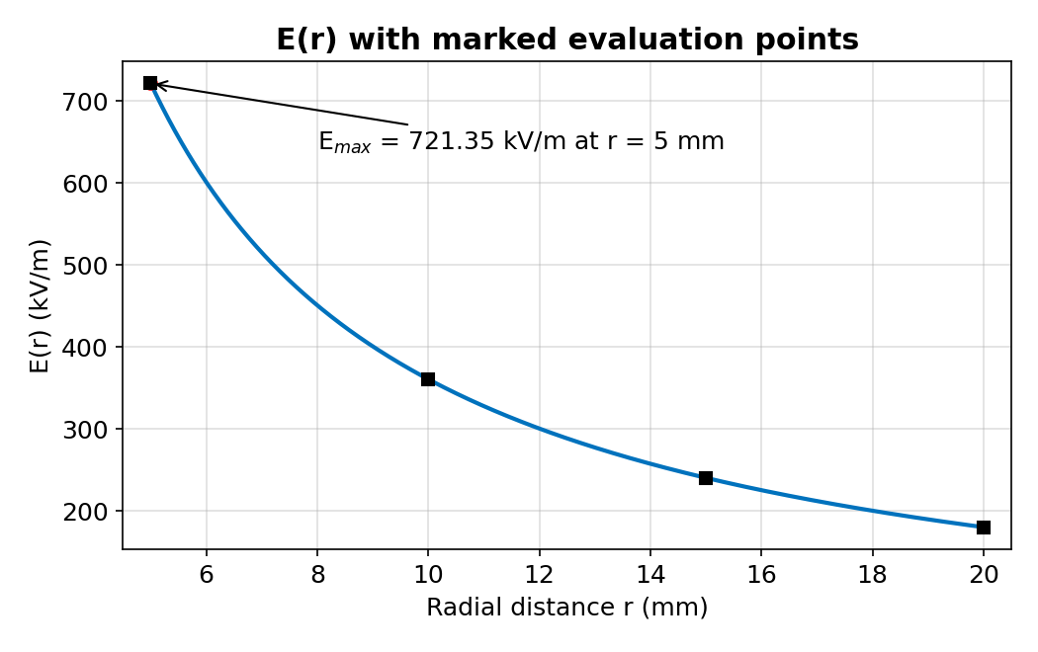
Figure 2: Electric field intensity E(r) with the maximum and the four required points marked
E(r) falls hyperbolically from 721.35 kV/m at the inner conductor to 180.34 kV/m at the shield. The maximum lies exactly on the surface of the inner electrode (r = 5 mm).
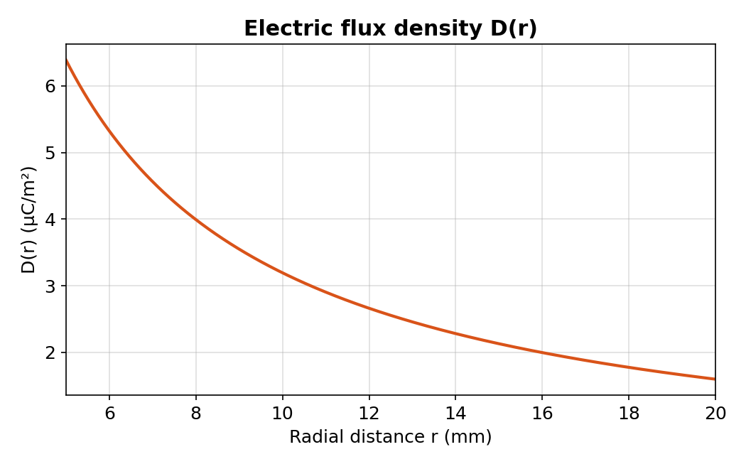
Figure 3: Electric flux density D(r)
D(r) has the same 1/r shape as E(r) because D = ε₀E. It falls from 6.387 to 1.597 μC/m².
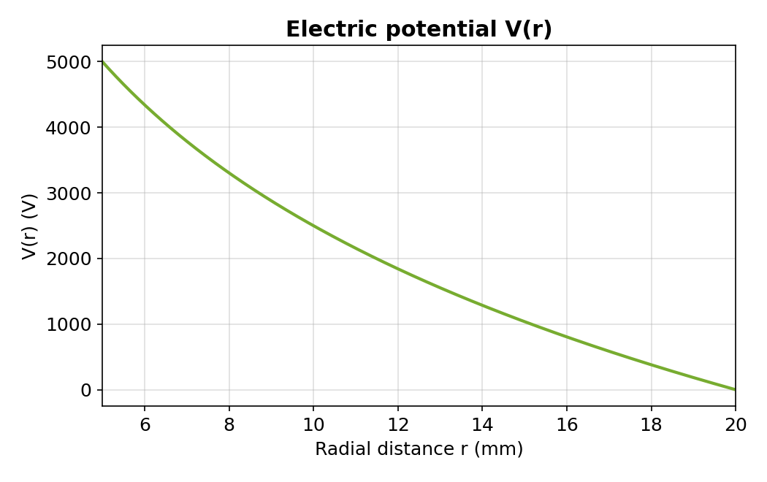
Figure 4: Electric potential V(r)
V(r) decreases logarithmically from 5000 V at r = a to 0 V at r = b. The slope is steepest near the inner conductor, consistent with the high field there.

5.6 Maximum field and its location
The MATLAB command [Emax, idx] = max(E) returns E_{max} = 721.35 kV/m and r(idx) = 5.0 mm, i.e. at the inner-conductor surface, as predicted analytically.

5.7 Numerical verification of analytical relationships
Relationship checked | Analytical | MATLAB | Error
V₀ = ∫E dr (trapz) | 5000 V | 5000.0018 V | 3.5 × 10⁻⁵ %
Q from Gauss flux at 10 mm | 20.0652 nC | 20.0652 nC | ≈ 0 (round-off)
W = ∫½εE² dv (trapz) | 50.16296 μJ | 50.16298 μJ | 3.5 × 10⁻⁵ %
E = −dV/dr (gradient) | E(r) | −∇V | ≤ 2.1 × 10⁻⁴ %

All numerical checks agree with the analytical expressions to better than 0.0003 %. The small remaining difference is the discretisation error of the trapezoidal rule and the central-difference gradient, which decreases as the grid is refined. The two required relationships (V₀ = ∫E dr and W = ½CV₀²) are therefore confirmed numerically.

6. STAGE 5 – ENGINEERING EVALUATION AND PARAMETER STUDY

6.1 Maximum field and field concentration
The maximum field is E_{max} = 721.35 kV/m. The average field across the gap would be V₀/(b − a) = 5000/0.015 = 333.33 kV/m (the value in a parallel-plate gap of the same spacing). The field-concentration factor is therefore
η = E_{max}/E_{avg} = (b − a)/[a ln(b/a)] = 15/(5 × 1.3863) = 2.16
The inner surface is stressed 2.16 times more than a uniform gap, and 4 times more than the shield surface (E_{max}/E(b) = b/a = 4).

6.2 Radial variation of E and D
Both E and D vary as 1/r. Doubling the radius from 5 mm to 10 mm halves the field (721.35 to 360.67 kV/m and 6.387 to 3.193 μC/m²), and doubling again to 20 mm halves it once more (180.34 kV/m and 1.597 μC/m²). The field at the shield is only 25 % of that at the inner conductor.

6.3 Potential distribution
The equipotential surfaces are coaxial cylinders. The potential is V = 5000 V at 5 mm, 2500 V at 10 mm, 1037.6 V at 15 mm and 0 V at 20 mm. The half-potential surface lies at the geometric mean r = √(ab) = 10 mm, not at the arithmetic mid-gap 12.5 mm.

6.4 Charge and stored energy
The structure stores Q = 20.07 nC and W = 50.16 μJ (501.6 μJ per metre). The energy density is w_{e} = ½ε₀E² = 2.30 J/m³ at r = a and only 0.144 J/m³ at r = b. The energy stored between r = a and r is W × ln(r/a)/ln(b/a), so 50 % of the energy lies between 5 and 10 mm, a region that occupies only 20 % of the air volume. This confirms that the stress and the energy are concentrated near the inner conductor.

6.5 Parameter study 1: effect of changing the inner radius a (b, L, V₀ fixed)
Using E_{max} = V₀/[a ln(b/a)], C = 2πε₀L/ln(b/a) and W = ½CV₀² with b = 20 mm, L = 100 mm and V₀ = 5 kV:
a (mm) | E_{max} (kV/m) | C (pF) | W (μJ)
2 | 1085.74 | 2.416 | 30.20
3 | 878.52 | 2.932 | 36.66
4 | 776.67 | 3.457 | 43.21
5 (design) | 721.35 | 4.013 | 50.16
6 | 692.15 | 4.621 | 57.76
7 | 680.39 | 5.299 | 66.24
7.36 (b/e) | 679.57 | 5.564 | 69.54
8 | 682.10 | 6.071 | 75.89
10 | 721.35 | 8.026 | 100.33
12 | 815.67 | 10.891 | 136.13
15 | 1158.69 | 19.338 | 241.73

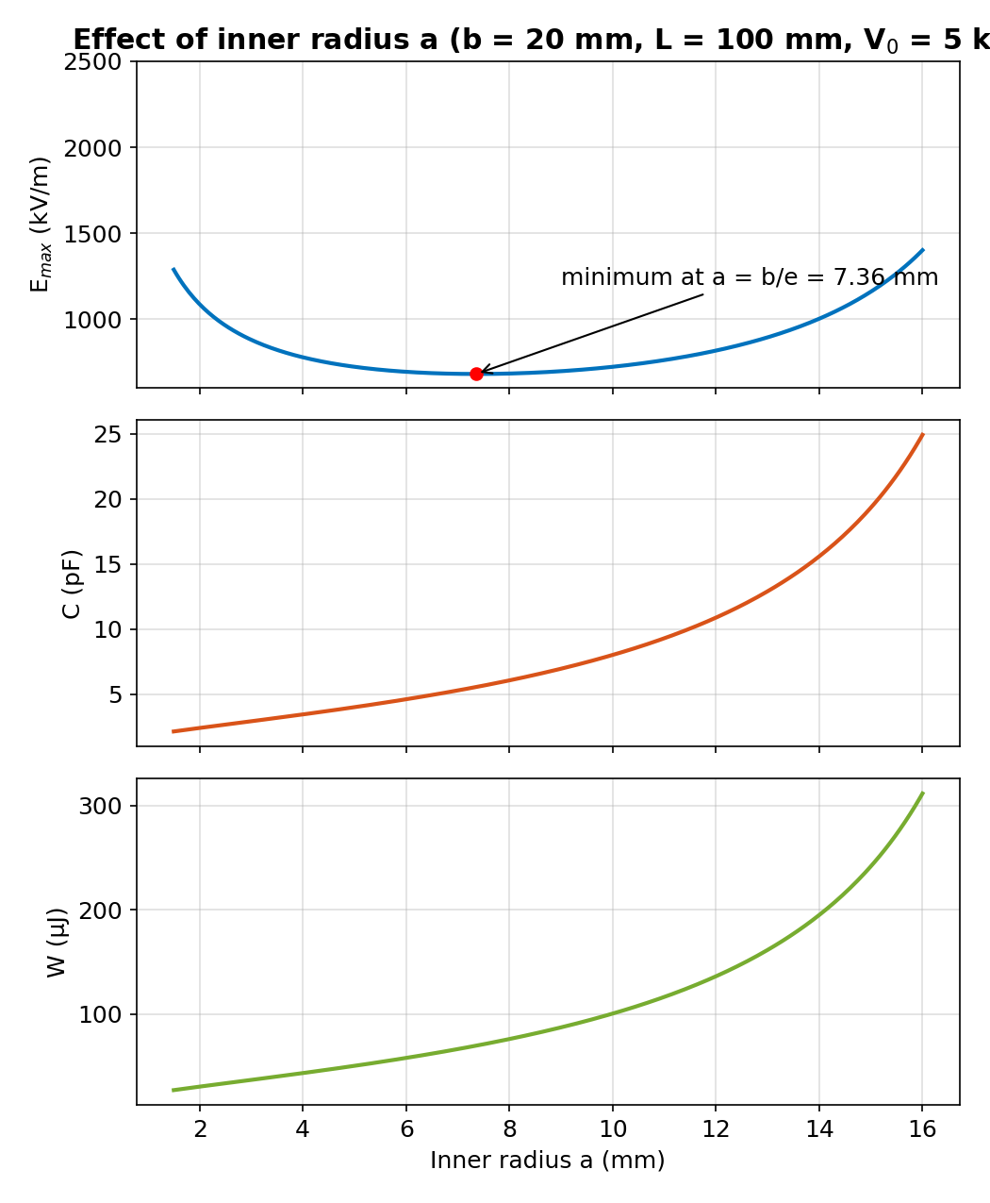
Figure 5: Effect of inner radius a on E_{max}, C and W
E_{max} first decreases and then increases as a grows. Setting dE_{max}/da = 0 gives ln(b/a) = 1, i.e. a = b/e = 7.36 mm, which minimises the maximum field at E_{max,min} = eV₀/b = 679.57 kV/m. Capacitance and energy increase monotonically with a. Very thin electrodes (a = 2 mm) are strongly penalised: E_{max} rises to 1085.74 kV/m.

6.6 Parameter study 2: effect of changing the outer radius b (a, L, V₀ fixed)
b (mm) | E_{max} (kV/m) | C (pF) | W (μJ)
10 | 1442.70 | 8.026 | 100.33
15 | 910.24 | 5.064 | 63.30
20 (design) | 721.35 | 4.013 | 50.16
25 | 621.33 | 3.457 | 43.21
30 | 558.11 | 3.105 | 38.81
40 | 480.90 | 2.675 | 33.44
50 | 434.29 | 2.416 | 30.20

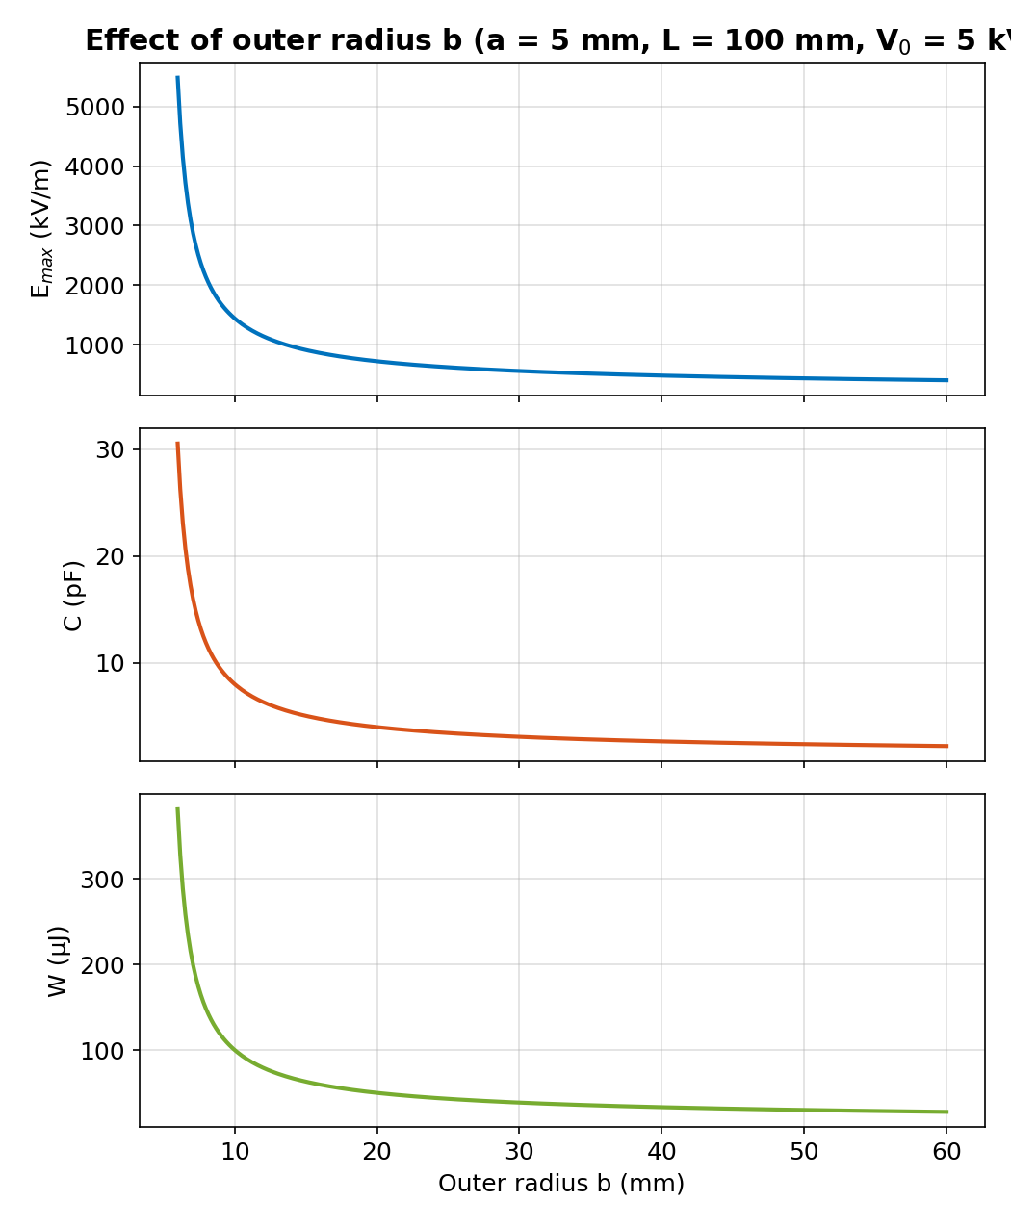
Figure 6: Effect of outer radius b on E_{max}, C and W
Increasing b reduces E_{max}, C and W, because the same 5 kV is spread over a longer gap. However, there is a diminishing return: raising b from 20 mm to 25 mm lowers E_{max} by 13.9 %, but from 40 mm to 50 mm only by 9.7 %, while the structure becomes much larger.

6.7 Recommended geometry
The numerical evidence shows that the present geometry (a = 5 mm, b = 20 mm) already gives E_{max} = 721.35 kV/m, which is only 6.2 % above the theoretical minimum (679.57 kV/m) for b = 20 mm, and the margin to the dielectric strength of air is large. The recommendation is to retain a = 5 mm and b = 20 mm. If a lower stress or a higher capacitance for sensing is desired, the optimum inner radius a = 7.36 mm may be adopted: it lowers E_{max} by 5.8 % (to 679.57 kV/m) and raises C and W by 38.6 % (to 5.564 pF and 69.54 μJ).

7. STAGE 6 – VERIFY AND CRITICALLY EVALUATE THE DESIGN

7.1 Plot and interpretation of E(r), D(r) and V(r)
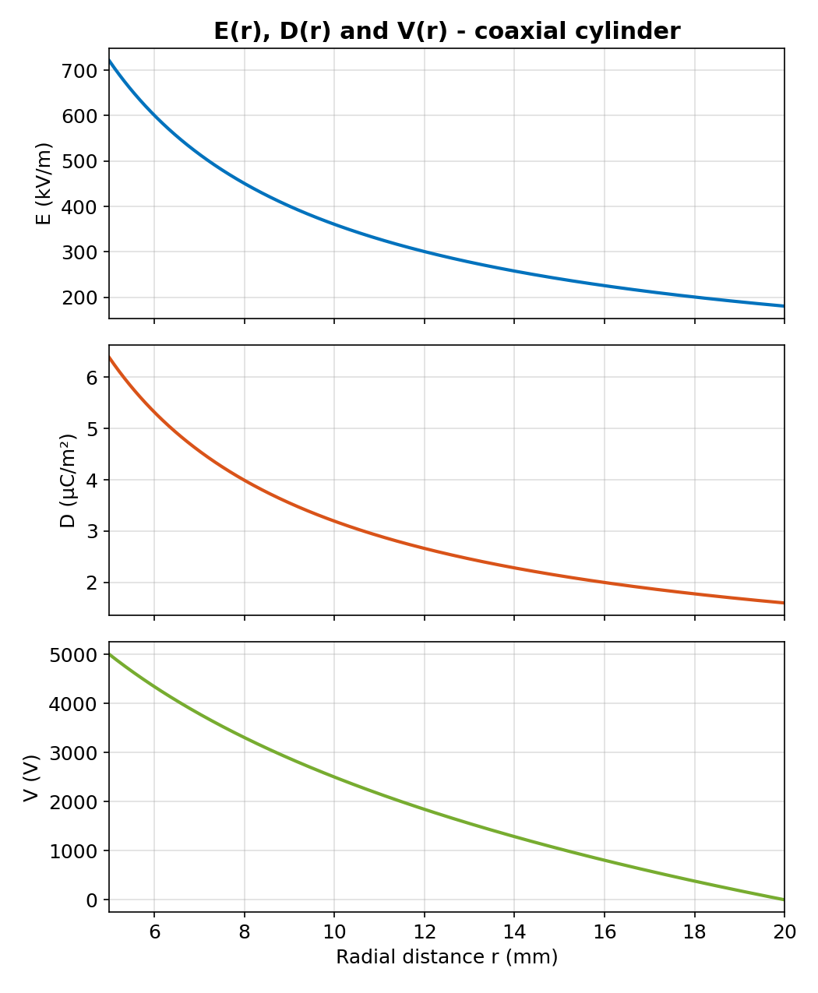
Figure 7: E(r), D(r) and V(r) between a = 5 mm and b = 20 mm
The three curves confirm the theory. E(r) and D(r) are monotonically decreasing with the same 1/r shape, and V(r) decreases logarithmically. The curves are smooth with no discontinuity in the air gap, as expected for a homogeneous medium.

7.2 Boundary conditions and the 5 kV potential difference
- Potential: V(a) = 5000 V and V(b) = 0 V, so the potential difference is exactly 5 kV.
- Tangential field: E is purely radial, so E_{t} = 0 on both conductor surfaces, as required for equipotential conductors.
- Normal flux density: D_{n} = ρ_{s}. At r = a, D = 6.387 μC/m² (positive surface charge); at r = b, D = 1.597 μC/m² directed into the shield (negative surface charge).
- Charge conservation: ρ_{s,a}(2πaL) = +20.07 nC and ρ_{s,b}(2πbL) = −20.07 nC, so the total charge is zero.

7.3 Charge and stored energy
The charge Q = 20.07 nC and the energy W = 50.16 μJ were obtained analytically, and verified numerically through the Gauss flux and the energy-density integral. Also W = ½QV₀ = ½(20.065 × 10⁻⁹)(5000) = 50.16 μJ, confirming consistency between charge and energy.

7.4 Analytical versus MATLAB comparison
Quantity | Analytical | MATLAB | % error
E_{max} at r = a | 721.3475 kV/m | 721.3475 kV/m | ≈ 0
V₀ (∫E dr) | 5000 V | 5000.0018 V | 3.5 × 10⁻⁵
Q (Gauss flux) | 20.0652 nC | 20.0652 nC | ≈ 0
C = Q/V₀ | 4.01304 pF | 4.01304 pF | ≈ 0
W (energy integral) | 50.16296 μJ | 50.16298 μJ | 3.5 × 10⁻⁵
E (−dV/dr) | E(r) | −∇V | ≤ 2.1 × 10⁻⁴
E at 10 mm (finite-line Coulomb) | 360.67 kV/m | 353.67 kV/m | 1.94

The percentage error is (|analytical − computed| / analytical) × 100. Six comparisons agree to better than 0.0003 %, which is only numerical round-off and discretisation error. The seventh comparison (1.94 %) is not a numerical error but a genuine physical difference: the finite length of the electrodes. It is small and justified, and it shows that the infinite-length model slightly over-estimates the field at the mid-plane of the 100 mm active region.

7.5 Field concentration, insulation implications and model limitations
The maximum field E_{max} = 721.35 kV/m is about 0.72 MV/m. Against the approximate dielectric strength of dry air (3 MV/m), the safety factor is 3/0.7213 = 4.16, i.e. the maximum field is 24 % of the breakdown value. Peek’s empirical corona-onset estimate for a smooth 5 mm radius cylinder is higher than 3 MV/m, so the 3 MV/m reference is conservative.
The limitations are the ideal assumptions listed in Stage 1: end and fringing effects (about 2 % at mid-plane), electrode eccentricity (which raises the field on the narrow side), surface roughness and sharp edges (local enhancement, so electrodes should be polished and edges rounded), humidity and pressure (the dielectric strength of air falls at low pressure or high humidity), and supports or spacers (a solid dielectric changes the field). A practical margin of at least 2 to 3 is normally required, and 4.16 comfortably meets it.

8. FINAL VERIFICATION TABLE
Requirement | Specified | Achieved | Satisfied?
Inner/outer geometry | a = 5 mm, b = 20 mm | a = 5 mm, b = 20 mm; b/a = 4 | Yes
Applied voltage | 5 kV | V(a) − V(b) = 5000 V | Yes
Field model | Valid for a < r < b | E = V₀/[r ln(b/a)] in a < r < b | Yes
Maximum electric field | Determine analytically | 721.35 kV/m at r = 5 mm (24 % of 3 MV/m) | Yes
Potential difference | 5 kV | 5000 V (numerical: 5000.0018 V) | Yes
Charge/energy consistency | Verified | Q = 20.07 nC, W = 50.16 μJ = ½QV₀ | Yes
Analytical–MATLAB agreement | Acceptable error justified | ≤ 2.1 × 10⁻⁴ %; finite-length 1.94 % | Yes

9. FINAL ENGINEERING DECISION
Decision: YES – the design is accepted.
Specification compliance: the geometry (a = 5 mm, b = 20 mm, L = 100 mm), the 5 kV potential difference and the 0 V reference at the outer conductor are all satisfied by the derived model E(r) = V₀/[r ln(b/a)], V(r) = V₀ ln(b/r)/ln(b/a), valid for a < r < b.
Numerical results: E_{max} = 721.35 kV/m at the inner conductor, ρ_{l} = 200.65 nC/m, Q = 20.07 nC, C = 4.013 pF and W = 50.16 μJ. The maximum field is 24 % of the approximate breakdown strength of air, a safety factor of 4.16.
Implementation practicality: Gauss’s law gives a closed-form solution that MATLAB evaluates and verifies in milliseconds. Analytical and MATLAB values agree to better than 0.0003 %, and the Coulomb cross-check confirms that end effects change the mid-plane field by only 1.94 %. A field solver such as CST Studio Suite may be used as an optional cross-check of the end regions.
Limitations: the model neglects fringing, eccentricity, surface roughness and environmental effects. The electrodes should be polished with rounded edges, concentric supports should be used, and a prototype high-voltage test should be performed.
Most important design parameter: the inner radius a. E_{max} = V₀/[a ln(b/a)] is most sensitive to a: reducing a to 2 mm would raise E_{max} to 1085.74 kV/m. The optimum a = b/e = 7.36 mm would reduce E_{max} by 5.8 % and is an optional refinement. Since the decision is YES, no mandatory redesign is needed.

10. CONCLUSION
The coaxial structure was analysed from requirement to decision. Gauss’s law was chosen as the primary method because it exploits the cylindrical symmetry and was supported by Coulomb’s law for cross-verification. The derived model was implemented in MATLAB, verified numerically with errors below 0.0003 %, explored through a parameter study, and checked against the specification. The geometry is safe, compliant and recommended for prototype fabrication.

APPENDIX A – MATLAB CODE FOR THE PARAMETER STUDY
%% Parameter study (needs eps, b, L, V0 from main)
a0 = 5e-3; % fixed inner radius
av = linspace(1.5e-3, 16e-3, 300); % a varies
Ea = V0./(av.*log(b./av));
Ca = 2*pi*eps*L./log(b./av);
Wa = 0.5*Ca*V0^2;
[Emin, i] = min(Ea);
fprintf('a_opt = %.2f mm, Emin = %.1f kV/m\n', ...
av(i)*1e3, Emin/1e3);

bv = linspace(6e-3, 60e-3, 300); % b varies
Eb = V0./(a0*log(bv/a0));
Cb = 2*pi*eps*L./log(bv/a0);
Wb = 0.5*Cb*V0^2;

figure;
subplot(3,1,1);
plot(av*1e3, Ea/1e3, 'LineWidth', 2);
ylabel('E_{max} (kV/m)'); grid on;
subplot(3,1,2);
plot(av*1e3, Ca*1e12, 'LineWidth', 2);
ylabel('C (pF)'); grid on;
subplot(3,1,3);
plot(av*1e3, Wa*1e6, 'LineWidth', 2);
ylabel('W (\muJ)'); xlabel('a (mm)'); grid on;

figure;
subplot(3,1,1);
plot(bv*1e3, Eb/1e3, 'LineWidth', 2);
ylabel('E_{max} (kV/m)'); grid on;
subplot(3,1,2);
plot(bv*1e3, Cb*1e12, 'LineWidth', 2);
ylabel('C (pF)'); grid on;
subplot(3,1,3);
plot(bv*1e3, Wb*1e6, 'LineWidth', 2);
ylabel('W (\muJ)'); xlabel('b (mm)'); grid on;

